EXERCISE 3
- List all employees whose last name begin with P.
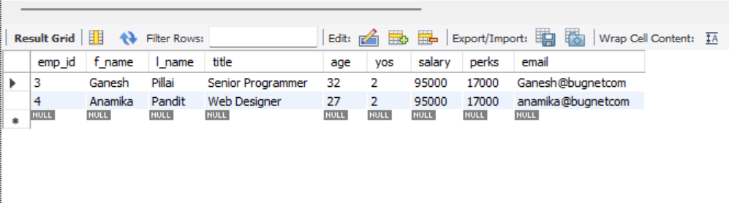
- Display the names of all employees in the marketing division.
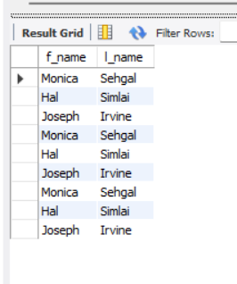
- What will the following statement display.
SELECT f_name, l_name, salary from employee_data where f_name like ‘%k%’;
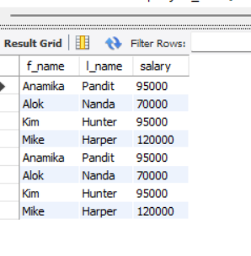
- List the last names and titles of all programmers.
